Chapter 6, Problem 8.

A 4-mF capacitor has the terminal voltage

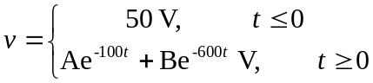

If the capacitor has initial current of 2A, find:
- the constants A and B,
- the energy stored in the capacitor at t = 0,
- the capacitor current for t > 0.

